**Angeles  City Science High School**

**English 9**

Name:Paul Gerald D. Pare  Section:9 - Adenine

D. Accomplish the plot diagram following the 5 elements of the story plot from

The Pardoner’s Tale. Write your answer on the box provided.

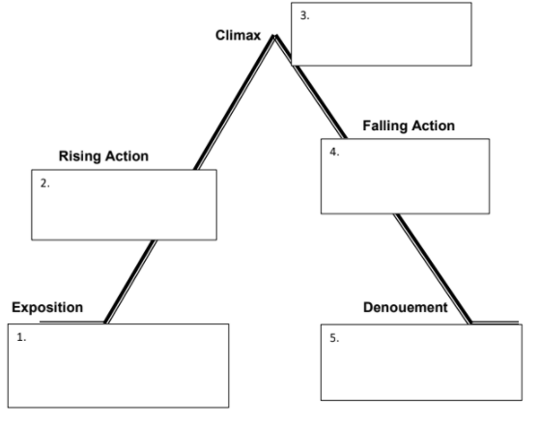

The pardoner’s preaching the crowd in Flanders telling the story of the three rioters.

They all died because all they cared about was money.

They started plotting each other’s death just to get the gold coins.

They found the gold under the oak tree.

Find out that their friend died and they want to find Death and kill him.

1. Comprehension Check:
2. According to the article, which is considered to be the crime of the year?

Corruption in PhilHealth.

2. How was the article about the PhilHealth connected to the story “The Pardoner’s

Tale”?

If they want to achieve something that they desire, they will cooperate with others. For the Pardoner’s Tale, they wanted to kill Death because their friend died due to him.

3. Why corruption happened amidst pandemic?

This could be because they are risking their lives for the others. It could also be the fact that they are treating a lot of patients therefore they want more money to obtain.

4. How did this corruption affect the people?

Our country already loss significant amount of networth and our economy is going down during this pandemic. This affects many people since we need more networth to grow back our economy. This also puts many workers before the pandemic to risks for they loss their jobs.

1. What important lesson can we get from both the story and the article?

Don’t be too greedy, this might come back to you into an unexpected bad effects. As the golden rule stated, “Don’t do it to other if you don’t want it to do to you.”

F. Make judgement on the values of the characters in the story “The Pardoner’s

Tale” and on the values of the people in the Article above. Focus on the most

essential values that should have been acceptable before and in modern society.

Explain your answer and write it on the space provided.

The pardoner is probably the best character that puts out good values to himself and he teaches others into doing something good by telling stories. He knows what to avoid and what is right. He is avoiding habits and activities that can harm him such as swearing, drinking alcoholic beverages, and other behaviours that most of the people at that time do. 1% improvement will pile up over time and we will get massive results therefore, self-improvement is good but a lot of people are going towards bad habits. They think it is fun even if for a short time. Bad habits that we do even if its small, it will add up and over the course of months, things will go badly. Even from the slightest detail of improvement, it will make a big difference. Starting now is better than later.